1.0 Introduction
Education plays an important role in the development of our nation not only in aspect of economy but to produce innovative and creative people that will make a great change to the whole country as well as to boost our economy at the global state. Without a proper education undertaken by the teachers or what so ever they claimed themselves, a student would not be able to reach the preliminary aims of the learning matters. As a matter of fact, educators are ought to be prepared in confronting any possibilities to happen.
Apparently, most of our lives nowadays seems to be associated with the technology invented by intelligent people from various part of the world. We could not deny how much technology had contributed to the evolution of the country. Thus, educators should realise and have to think innovatively to perform the modern style of teaching which is by utilising the internet during the teaching and learning process in the classroom, and not to stick with the traditional pedagogy as era of globalization has growing so rapidly.
Over the last few years, 'Web 2.0' or 'social computing' applications like blogs, wikis, photos and video-sharing sites, and also online social networking sites and virtual worlds, have seen unprecedented take up. Research evidence suggests that these online tools have not only affected people’s private and professional lives, but are also starting to transform learning patterns and pathways. However, due to the originality of social computing, take up in formal Education and Training is still in an experimental phase. As a consequence, data and scientific evidence on the current use and potential impact of Learning 2.0 strategies is lacking.
In order to investigate how social computing applications can be used in organised learning settings to enhance learning activities and promote innovation and inclusion in Education, an exploratory study employing a triangulation of different research methodologies was conducted. The findings of this Learning 2.0 study are synthesised in this report.

2.0 Literature Review
As for educators, learning web 2.0 strategies for promoting innovation and inclusion and points out challenges to mainstream deployment is crucial. The evidence gathered suggests that Learning 2.0 approaches can facilitate technological, pedagogical and organisational innovation in Education and thus contribute to the modernisation of local education deemed necessary to face the challenges of the 21st century.
Web 2.0 is the network as platform, spanning all connected devices; Web 2.0 applications are those that make the most of the intrinsic advantages of that platform: delivering software as a continually-updated service that gets better the more people use it, consuming and remixing data from multiple sources, including individual users, while providing their own data and services in a form that allows remixing by others, creating network effects through an "architecture of participation," and going beyond the page metaphor of Web 1.0 to deliver rich user experiences (Tim O’Reilly 2004). It also be known as the second stage of development of the Internet, characterized especially by the change from static web pages to dynamic or user-generated content and the growth of social media (Oxford Dictionaries)
Education is basically defined as a wise, hopeful and respectful cultivation of learning undertaken in the belief that all should have the chance to share in life. Education, as we understand it here, is a process of inviting truth and possibility, of encouraging and giving time to discovery. It is, as John Dewey (1916) put it, a social process – ‘a process of living and not a preparation for future living’.
This exploratory study aims to probe how Web 2.0 could be made use by the educators at any institutions particularly among university communities. There are three specific objectives of the study. Firstly, to identify the benefits or goodness of using Web 2.0 in our education system. Secondly, to examine the best practices or effective methods that can be done to apply Web 2.0 in our education system. Third, to investigate whether Web 2.0 is relevant to be performed during Teaching and Learning process.

3.0 Methodology
This exploratory research uses both qualitative and quantitative approaches. Creswell (2003), Cherryholmes (1992) and Murphy (1990) highlight the need for researchers to have a freedom of choice in search of the truth. They draw attention to the aim of conducting any research as searching for the truth and researchers may use mixed methods to provide the best understanding of the research problem. Both qualitative and quantitative techniques are applied to explore views on the use of web 2.0 among university students. The sample size, which is large enough, qualifies for quantitative approach. In addition, results from the survey are quantitatively analysed, using inferential statistics. Data obtained from the survey are also presented quantitatively, in the form of tables and charts to facilitate data interpretation.
Survey is preferred to interview because the sampling size is quite large. Hence, it is time consuming to conduct personal interview. To provide and gather as much information and relative evaluation, descriptive method was used. This method includes the use of questionnaires and interviews. A questionnaire was used as the main data-gathering instrument for this study. It was divided into three main sections: the profile and questionnaire proper’s. The profile consists of gender, age, religion, level of education, and field of study.
The survey questions were virtually distributed among various students using google form. The reason why google form had been taken as a method of distributing the questionnaire is because people can effortlessly access through it anywhere and anytime by the condition to have internet connection. Responses from the survey were keyed-in automatically in google forms. Thus, it is easier to make data analysis as it already well-organized in google forms. Following the quantitative approach, the research is carried out among Malaysia’s university students. The result ended up to have 52 respondents altogether.

4.0 Findings
4.1 Demography of Respondents
4.1.1 Gender
A total of 52 respondents of students in Universities throughout Malaysia were surveyed. The background of the respondents in terms of gender, races, age, religion, level of education and field of study are described in the table and pie chart by entering the number percent of respondents.

Table 1: Demographic of Gender
Gender | Numbers of Persons | Percentage (%)
Boys | 9 | 17.3
Girls | 43 | 82.7
Total | 52 | 100

Figure 1: Demographic of Gender
According to the study, of the 52 respondents, nine respondents (17.3%) were male respondents, while 42 respondents (47%) is made up of girls. This shows there is a difference gap is quite big between male and female respondents, despite the selection of respondents is done randomly. Further information can be seen in Figure 1. Although there are gaps in gender selection of respondents, this study aims to examine the perception of web 2.0 usage among University’s students throughout Malaysia.

4.1.2 Religion
According to the study, of the 52 respondents, 43 people (82.7%) is made up of Muslim respondents, while 1 people (1.9%) are students who believe in Buddhism, followed by Christians of six persons (11.5%), Students who follow other religions such as Hinduism did get the respondents of 2 people (3.8%). Islam can be summarized that students prefer to use web 2.0 applications when doing something compared with students who believe in Buddhism and Christianity.

Table 2: Demographic of Religion
Religion | Numbers of Person  (person) | Percentage  ( % )
Muslim | 43 | 82.7
Buddhist | 1 | 1.9
Christian | 6 | 11.5
Hindu | 2 | 3.8
Others | 0 | 0
Total | 52 | 100

Figure 2: Demographic of Religion

4.1.3 Level of Education
Level of education are indeed important as we measure how frequent does the students use the web 2.0 in their daily basis or when they are making an assignment according to their level of education. Basically, from the 52 respondents, 44 of them are students who are currently pursuing the study in undergraduate level, which dominate 84.5% of the respondents. Nonetheless, there are seven students (13.5%) and one student (1.9%) both are in diploma and post graduate level respectively.

Table 3: Demographic of Level of Education
Level | Numbers of Person  (person) | Percentage  ( % )
Diploma | 7 | 13.5
Undergraduate | 44 | 84.6
Postgraduate | 1 | 1.9
Total | 52 | 100

4.1.4 Field of Study
The process of investigating the usage of web 2.0 includes the student’s field of study in the university. About 25 out of the 52 respondents or 48.1% of respondents from the Faculty of Education were participated in this survey. While 15 students (28.8%) are from the Faculty of Social Science and Humanities. Nonetheless, there are no student participated in this survey from the Faculty of Architecture, Faculty of Islamic Study and Faculty of Law.

Table 4: Demographic of Field of Study
Field of Study | Numbers of Person  (person) | Percentage  ( % )
Faculty of Education (TESL) | 20 | 38.5
Faculty of education (Special Education) | 4 | 7.7
Faculty of Education (Sports and Recreations) | 1 | 1.9
Faculty of Architecture | 0 | 0
Faculty of Economics | 3 | 5.8
Faculty of Engineering | 1 | 1.9
Faculty of Information Technologies | 2 | 3.8
Faculty of Islamic Study | 0 | 0
Faculty of Law | 0 | 0
Faculty of Social Science and Humanities | 15 | 28.8
Faculty of Science and Technology | 6 | 11.5
Total | 52 | 100

4.2 Analysis on usage of Web 2.0 among students
Table 5: Likert Scale
Matter | Strongly Agree | Agree | Neutral | Disagree | Strongly Disagree
Score | 1 | 2 | 3 | 4 | 5

4.2.1 Printed materials should be abolished and replaced by computer aided learning in classroom

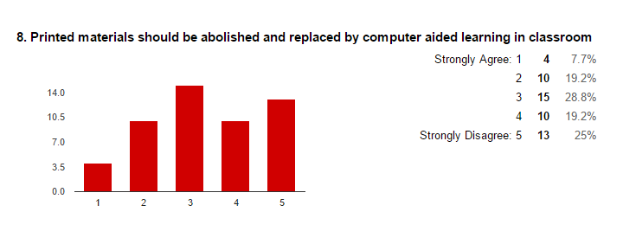
Figure 3: The figure shows the bar graph of comparison between learning through ICT or printed materials

Nowadays, people are more likely to use computer materials instead of printed materials. Computer materials such as Power point or online presentation such as Prezi because it gained more popularity as we live in 21st century world where technology spearhead our daily basis. But it depends on the students itself whether they like to use manuals materials or computer aided learning in classroom. The table shows the analysis of items closer ties between students in Malaysia’s University. Only four respondents (7.7%) of respondents surveyed strongly agree that they wanted computer to be aided in learning process between participants involved. While 10 patients (19.2%) of respondents agreed and 15 patients (28.8%) are not sure of the item. 10 respondents (19.2%) did not agree with this item while 13 respondents (25%) are strongly disagree. This shows that printed materials are still important to students these days.

4.2.2 Web 2.0 enriches the interaction and communication among educators and students

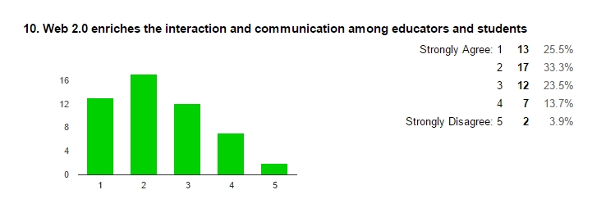
Figure 4: The bar graph shows the interaction between educators and students

The table shows matter of web 2.0 which can enrich the interaction and communication among the educators and students. A total of 13 respondents (25.5%) strongly agree and 12 respondents (23.5%) are not sure with this item. 17 respondents (33.3%) out of 52 people agreed while disagree recorded seven respondents (13.7%), and two (3.9%) of respondents said strongly disagree with this item. So, majority of the students agreed that the web 2.0 can enriches their interaction and communication among educators and students.

4.2.3 Web 2.0 tools like social networking and blog can help students understand better about the learning.

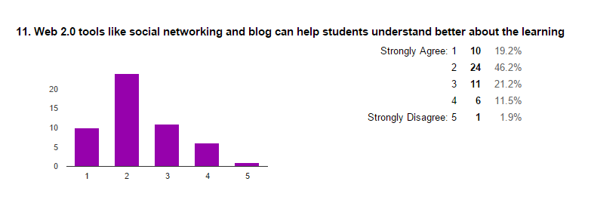
Figure 5: The Bar graph indicates the understanding of students when using web 2.0

Next, the table shows the understanding of students when using web 2.0 platform like social networking and blog can improve their learning process. In 10 respondents (19.2%) of the 52 respondents, they strongly agreed that this phase could nourish their knowledge. While 11 respondents (21.2%) are not sure with this item. There are one respondents (1.9%) respondents strongly disagreed with this item.

4.2.4 Social media helps to improve students’ achievement

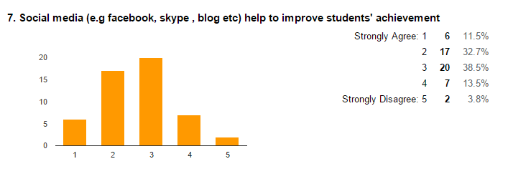
Figure 6: A bar graph of students’ performances through social media

According to the table, 20 respondents (38.5%) were not sure whether social media can improve their achievement which marks the highest reading while there are only five respondents (3.8%) out of 52 respondents strongly disagree with this item. There are only six respondents who admit that social media can improve their academic performances.

4.2.4 Web 2.0 can assist to build a sense of community among student.

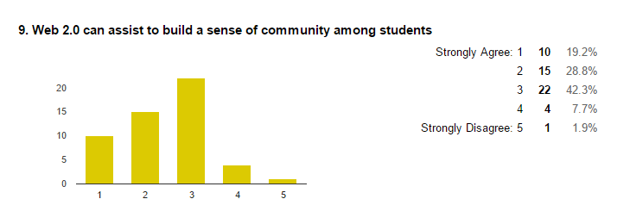
Figure 7: A bar graph of sense of community among students
Based on the table, A total of 10 respondents (19.2%) strongly agree and 22 respondents (42.3%) are not sure with this item. 15 respondents (28.8%) out of 52 people agreed while disagree recorded four respondents (7.7%), and one (1.9%) of respondents said strongly disagree with this item that web 2.0 can assist them to build a sense of community.

4.2.5 Online presentation tools such as Prezi and Mindomo are easy to use compared to Microsoft Powerpoint.
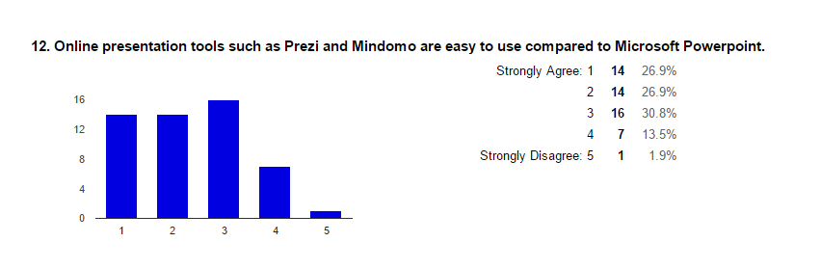
Figure 8: The bar graph shows the comparison between online and offline presentation tools

The table indicates the easiest way of using a presentation tools. A total of 21 respondents (53.8%) strongly agree and agree while 16 respondents (30.8%) are not sure with this item. seven respondents (13.5%) out of 52 people disagree, and strongly disagree recorded one respondent (1.9%). Basically, most of the students do not sure whether they like using an online or offline presentation tools

4.2.6 Web 2.0 makes users’ privacy to be too opened that could lead to uneasiness

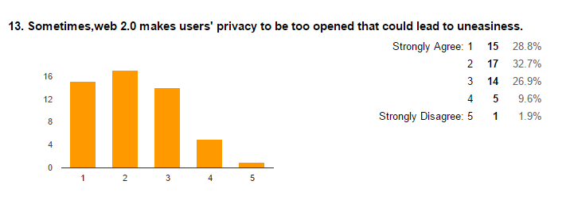
Figure 9: A bar graph of web 2.0 privacy’s

In 15 respondents (28.8%) of the 52 respondents, they strongly agreed that this activity could lead to uneasiness. 14 respondents (26.9%) are not sure with this item. There are one respondents (1.9%) respondents strongly disagreed with this item. While the rest are disagreed with five persons (9.6%) and agreed with 17 respondents (32.7%) respectively.

4.2.7 Technical problem is one of the Web 2.0 problems.

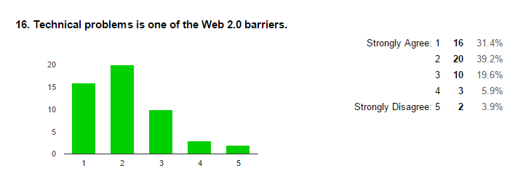
Figure 10: The bar graph indicates the technical problems faced by web 2.0 users.
The table shows the technical problem on Web 2.0. There are 20 respondents (39.2%) agreed while 16 respondents (31.4%) strongly agreed that there are technical problems in using Web 2.0. 10 respondents out of 52 were not sure about this and three respondent (5.9%) disagree about this while the rest (3.9%) are strongly disagree that technical problem is one of the web 2.0 problems.

4.2.8 Web based learning allows students to share ideas not only among their own friends, but international access.

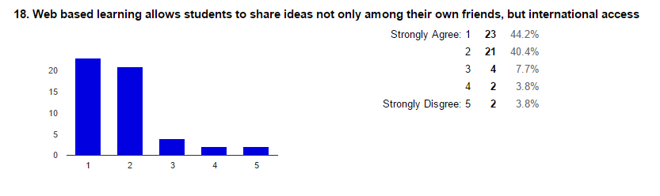
Figure 11: A bar graph shows the platform to share the ideas among students
The table indicates the web based learning. There are 23 respondents (44.2%) strongly agreed while 21 respondents (40.4%) agreed that web based learning allows students to share ideas globally. Strongly disagree and disagree recorded the same reading which is two respondents respectively (3.8%) while four respondents (7.7%) were not sure about this.

4.3 Students Perspective

4.3.1 Web 2.0 can improve students’ skills in technology

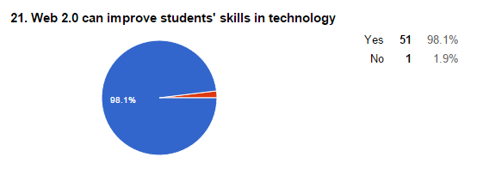
Figure 12: The pie chart shows the result of the improvement in technology among students

Based on the analysis result, a total of 51 respondents (98.1%) of respondents said web 2.0 can improve students’ skills in technology, by learning through web 2.0, it allows students to improve their skill in using online platform. While only one respondent (1.9%) did not agree with this opinion.

4.3.2 Web 2.0 helps in getting new or existing information
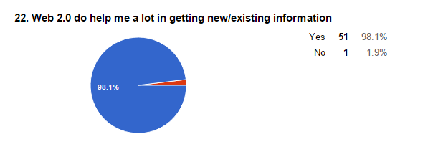
Figure 13: The pie chart indicates the result in getting information among students
Figure 13 shows respondents' perceptions of the web 2.0 in gaining new information, the majority of respondents agreed that web 2.0 do help a lot in searching or receiving new information. A total of 51 (98.1%) of respondents agreed that web 2.0 can help them in getting new or existing information. While one respondent (1.9%) disagree that this platform can help them.

4.3.3 Web 2.0 can clarify the instruction, task and frequent feedback for the students.

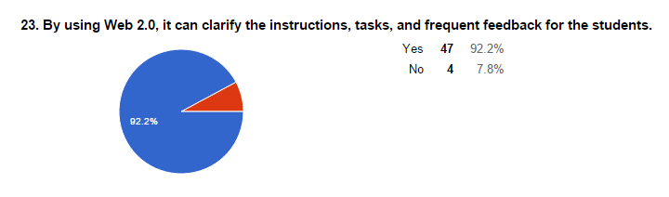
Figure 14: A pie chart of the result in advantages of web 2.0

The table shows web 2.0 feedback for the students. A total of 47 respondents (92.2%) of respondents agreed that web 2.0 can clarify the instruction, task and frequent feedback for the students, while four respondents (7.8%) were not.

4.3.4 I am interested to know more about web 2.0 and plan to practice it in my learning process

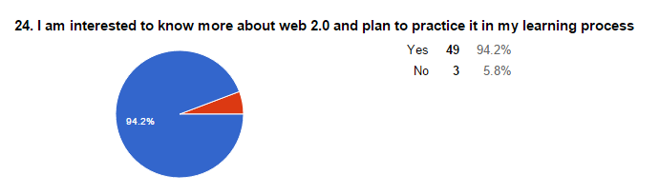
Figure 15: A pie chart of the result in using web 2.0 in daily basis

According to the figure, 94.2% or 49 of respondent agreed to know more about web 2.0 and plan to practice it in their learning process which marks the highest percentage while only 5.8% or 3 respondents disagree to know more about web 2.0 and practice in learning process.

4.3.5 Web 2.0 makes life easier

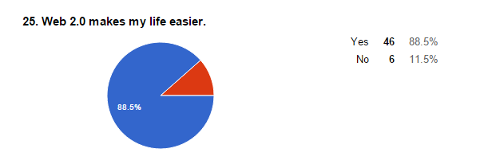
Figure 16: The pie chart shows whether web 2.0 can make students’ life easier or not

The table indicates respondents' perceptions of the web 2.0 in making their life easier, the majority of respondents agreed that web 2.0 do help them a lot in doing a research especially when they want to search for information. A total of 46 (88.5%) of respondents agreed that web 2.0 can help them in getting new information. While six respondents (11.5%) disagree that web 2.0 can help or making their life easier.

5.0 Conclusion

As a conclusion, web 2.0 nowadays are widely used in educational field. Almost all the country implementing the web 2.0 in their educational system. Due to advances in programming, users are no longer passive and become designers of content through blogs and platforms like YouTube, Facebook and Twitter. This platform usually gives the chances to the groups or communities to share and generate knowledge. In Malaysia, the uses of web 2.0 in education actually contains pros and cons which are widely argued by the intellectual. Last but not least, education must take this series of resources not only as something meant only for leisure, but that should be seen as a series of working tools that must be seized as didactically develop a set of skills that will later be used in the labor market or own learning.

List of References
Brian Kelly, Lawrie Phipps, Mark Hepworth, Randy Matcalfe (2007); What is Web
2.0? Ideas, Technologies, and Implication for Education by Paul Anderson;
JISC Technology and Standards Watch (Feb. 2007)
Creswell, J. (2003) Research Design: Qualitative, Quantitative and Mixed Methods
Approaches. Second Edition. Thousand Oaks, CA: Sage
Philip W. Jackson (2011). What is Education? ; University of Chicago (6 Jan. 2012)
Margaret Rouse, Matthew Haughn (2015, January) What is Web 2.0, The definition.
Retrieved November 29, 2015 from
http://whatis.techtarget.com/definition/Web-20-or-Web-2
Richard Noss (2007). Education 2.0? Designing the Web for Teaching and Learning
TLRP-TEL University of London. Retrieved November 6, 2015 from
http://www.tlrp.org/pub/documents/TELcomm.pdf

Paul Anderson (2012) Web 2.0 and Beyond: Principles and Technologies

Chapman & Hall/CRC Textbooks in Computing (Book 7) ; Chapman and

Hall/CRC; First edition (May 15, 2012)
Smith, M. K. (2015). What is education? A definition and discussion.
The encyclopaedia of informal education. Retrieved November 29, 2015 from
http://infed.org/mobi/what-is-education-a-definition-and-discussion/.

Dewey, J. (1916), Democracy and Education. An introduction to the

philosophy of education (1966 edn.). New York: Free Press

